**1.Two Sum**

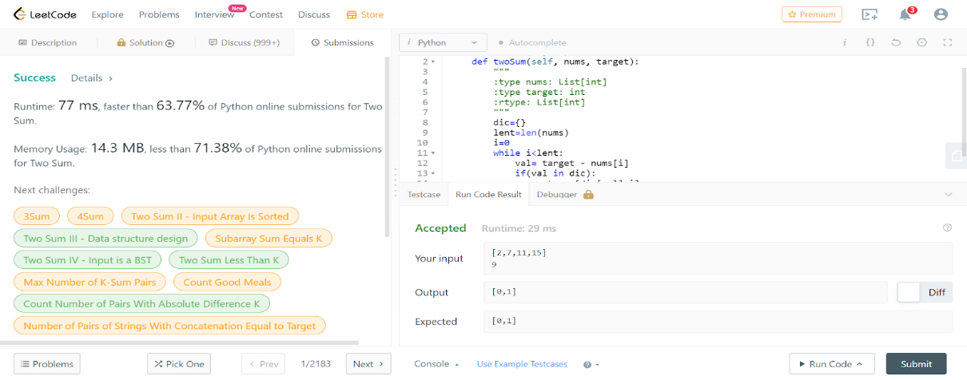

class Solution(object):

    def twoSum(self, nums, target):

        """

        :type nums: List[int]

        :type target: int

        :rtype: List[int]

        """

        dic={}

        lent=len(nums)

        i=0

        while i<lent:

            val= target - nums[i]

            if(val in dic):

                return [dic[val],i]

            dic[nums[i]]=i

            i+=1

**26.Remove Duplicates from Sorted Array**

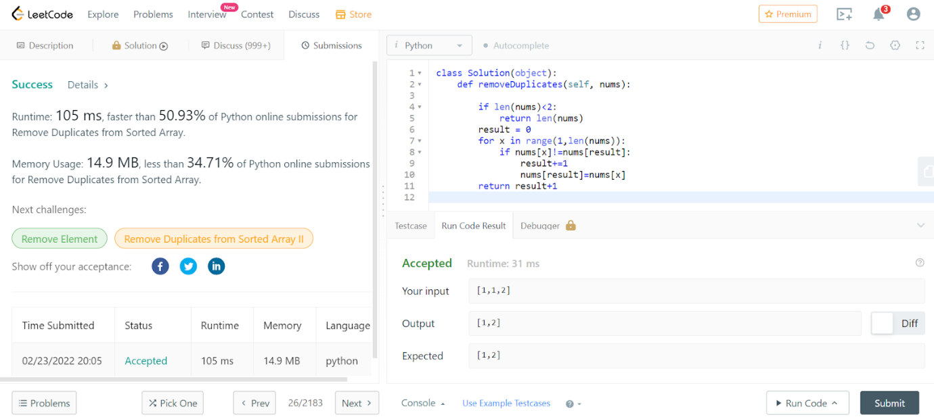

class Solution(object):

    def removeDuplicates(self, nums):

        if len(nums)<2:

            return len(nums)

        result = 0

        for x in range(1,len(nums)):

            if nums[x]!=nums[result]:

                result+=1

                nums[result]=nums[x]

        return result+1

**27. Remove Element**

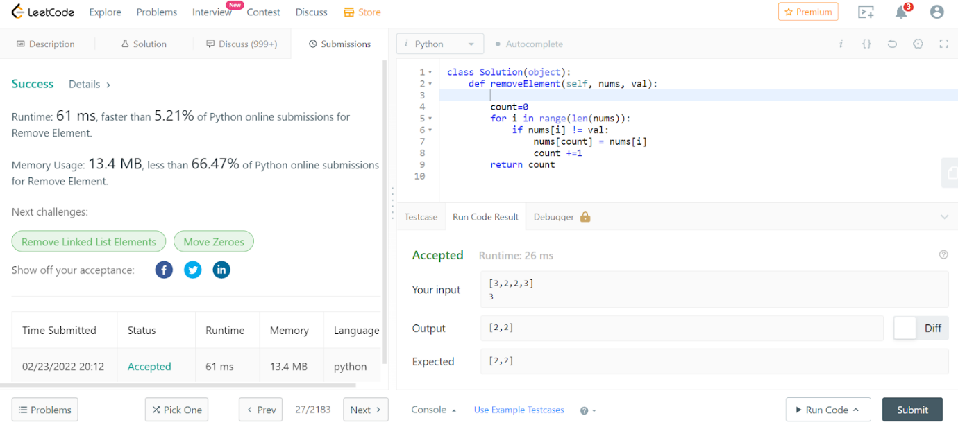

class Solution(object):

    def removeElement(self, nums, val):

        count=0

        for i in range(len(nums)):

            if nums[i] != val:

                nums[count] = nums[i]

                count +=1

        return count

**35. Search Insert Position**

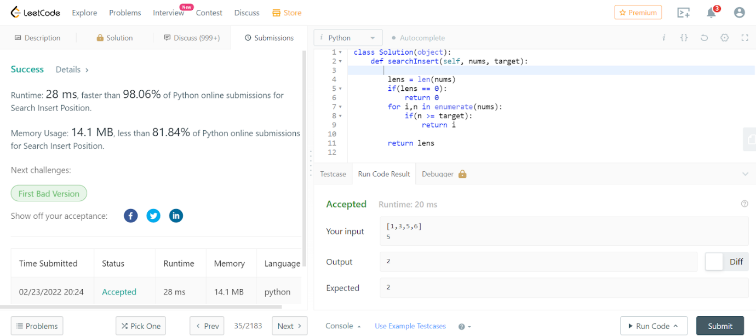

class Solution(object):

    def searchInsert(self, nums, target):

        lens = len(nums)

        if(lens == 0):

            return 0

        for i,n in enumerate(nums):

            if(n >= target):

                return i

        return lens

**53. Maximum Subarray**

class Solution(object):

    def maxSubArray(self, nums):

        """

        :type nums: List[int]

        :rtype: int

        """

        sums = maxs = nums[0]

        for i in range(1,len(nums)):

            sums = max(sums+nums[i],nums[i])

            maxs = max(sums,maxs)

        return maxs

66. Plus One

class Solution(object):

    def plusOne(self, digits):

        result = []

        str_digits = ''.join(str(i) for i in digits)

        int_digits = int(str_digits) + 1

        str_digits = str(int_digits)

        for i in str_digits:

            result.append(int(i))

        return result

**88. Merge Sorted Array**

class Solution(object):

    def merge(self, nums1, m, nums2, n):

        nums1[:] = sorted(nums1[:m] + nums2[:n])